Ordinal Encoding

Definition
# Source: AI Source: Provided by: [Data Path: Persons Table -> ID Column: 1, Name_En Column: Motasem Essam] -> From: [Chatgpt (GPT‑5 Mini)] on [12/10/2025]
Ordinal Encoding is a method used to convert categorical variables with a natural order into numerical values. Each category is assigned a number that reflects its rank or order.
This method is suitable for categorical variables where the order of categories is meaningful.

Key Idea
# Source: AI Source: Provided by: [Data Path: Persons Table -> ID Column: 1, Name_En Column: Motasem Essam] -> From: [Chatgpt (GPT‑5 Mini)] on [12/10/2025]
Categories are replaced with numbers that represent their logical order.
Example:

Education Level | Encoded Value
High School | 1
Bachelor | 2
Master | 3
PhD | 4
In this case, the numbers represent the increasing level of education.

How It Works
# Source: AI Source: Provided by: [Data Path: Persons Table -> ID Column: 1, Name_En Column: Motasem Essam] -> From: [Chatgpt (GPT‑5 Mini)] on [12/10/2025]
- Identify categorical variables that have a natural ranking.
- Assign numbers based on the order of the categories.
- Replace the categorical values with the corresponding numbers.

Example
# Source: AI Source: Provided by: [Data Path: Persons Table -> ID Column: 1, Name_En Column: Motasem Essam] -> From: [Chatgpt (GPT‑5 Mini)] on [12/10/2025]
Original dataset:

Student | Education Level
1 | High School
2 | Bachelor
3 | Master
4 | PhD
After Ordinal Encoding:

Student | Education Level
1 | 1
2 | 2
3 | 3
4 | 4

Advantages
# Source: AI Source: Provided by: [Data Path: Persons Table -> ID Column: 1, Name_En Column: Motasem Essam] -> From: [Chatgpt (GPT‑5 Mini)] on [12/10/2025]
- Preserves the order or ranking between categories
- Requires less memory than one-hot encoding
- Simple and easy to implement

Disadvantages
# Source: AI Source: Provided by: [Data Path: Persons Table -> ID Column: 1, Name_En Column: Motasem Essam] -> From: [Chatgpt (GPT‑5 Mini)] on [12/10/2025]
- Assumes the distance between categories is equal, which may not always be true
- Not suitable for nominal categorical variables (categories with no natural order)

Example in a Survey Dataset
# Source: AI Source: Provided by: [Data Path: Persons Table -> ID Column: 1, Name_En Column: Motasem Essam] -> From: [Chatgpt (GPT‑5 Mini)] on [12/10/2025]
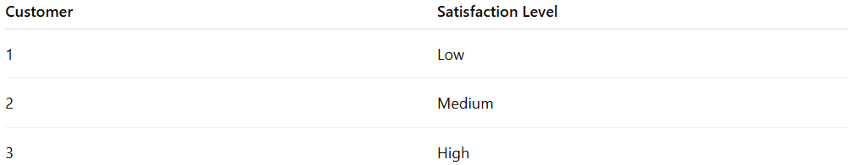
Customer | Satisfaction Level
1 | Low
2 | Medium
3 | High
After Ordinal Encoding:

Customer | Satisfaction Level
1 | 1
2 | 2
3 | 3

